IMPACT OF BIOMETRIC AUTHENTICATION AND ITS USE IN ENHANCING SECURITY

USA TUMBAGIMA VANDI
(ST/CS/ND/21/107)

A SEMINAR PRESENTED TO THE DEPARTMENT OF COMPUTER SCIENCE, SCHOOL OF SCIENCE AND TECHNOLOGY, FEDERAL POLYTECHNIC MUBI, ADAMAWA STATE, NIGERIA

AUGUST, 2023

IMPACT OF BIOMETRIC AUTHENTICATION AND ITS USE IN ENHANCING SECURITY

USA TUMBAGIMA VANDI
(ST/CS/ND/21/107)

A SEMINAR PRESENTED TO THE DEPARTMENT OF COMPUTER SCIENCE, SCHOOL OF SCIENCE AND TECHNOLOGY, FEDERAL POLYTECHNIC MUBI, ADAMAWA STATE, NIGERIA

IN PARTIAL FULFILLMENT OF THE REQUIREMENTS FOR THE AWARD OF NATIONAL DIPLOMA (ND) IN COMPUTER SCIENCE

AUGUST, 2023

Abstract
Biometric authentication, a technology that relies on unique biological and behavioral traits for identity verification, has emerged as a pivotal solution in bolstering security across various domains. This paper presents a comprehensive overview of the advantages, disadvantages, features, and recent developments in biometric authentication. The technology's ability to offer enhanced security through traits that are difficult to replicate, its user-friendly nature, and potential for dynamic authentication are highlighted as key features. Recent research insights emphasize advancements such as deep learning for accuracy improvement, multi-modal fusion for robustness, and anti-spoofing techniques for countering attacks. Privacy concerns, accuracy challenges, and the high implementation costs are identified as notable disadvantages. Drawing from recent citations, this paper provides a balanced assessment of the impact of biometric authentication on cybersecurity and offers recommendations for effective and ethical implementation. By acknowledging its strengths and limitations, organizations can harness biometric authentication's potential to augment security while addressing the concerns associated with this technology.
Keywords: Biometric authentication, security, advantages, disadvantages, features, recent developments, deep learning, multi-modal fusion, anti-spoofing, privacy concerns.

Introduction
In an increasingly digitized world, where sensitive information and transactions are conducted online, the need for robust security measures has become paramount. Traditional methods of authentication, primarily reliant on passwords, have demonstrated vulnerabilities and limitations, prompting the exploration of more advanced and secure alternatives. Biometric authentication, a cutting-edge technology that employs unique biological traits for identity verification, has emerged as a transformative solution in this landscape. In today's digital age, where cybersecurity threats are ever-evolving, the need for robust authentication methods has become paramount. Biometric authentication has emerged as a game-changing technology that not only enhances security but also offers a convenient and user-friendly way to verify individuals' identities. This technology relies on unique biological and behavioral characteristics, such as fingerprints, facial features, iris patterns, voice, and even typing patterns, to provide a highly secure and personalized form of authentication (Raghavendra et al., 2023).
Biometric authentication refers to a cybersecurity process that verifies a user’s identity using their unique biological traits such as fingerprints, voices, retinas, and facial features. Biometric authentication systems store this information in order to verify a user’s identity when that user accesses their account. This type of authentication is usually more secure than traditional forms of multi-factor authentication. The conventional paradigm of security often relies on what the user knows (passwords) or possesses (tokens), but these factors can be compromised through various means, ranging from data breaches to social engineering. Biometric authentication represents a paradigm shift by introducing what the user inherently is—an individual with distinctive biological attributes that are exceedingly difficult to replicate. Biometric traits such as fingerprints, facial features, iris patterns, voiceprints, and even behavioral nuances like typing patterns are captured and converted into digital templates. These templates serve as unique identifiers that differentiate one individual from another. Unlike passwords, which can be forgotten, shared, or stolen, biometric traits remain constant and personal, offering a higher level of security (Rashed-Al-Mahfuz et al., 2020)
The Rise of Biometric Authentication: The proliferation of biometric authentication across various domains underscores its growing significance in the realm of security. Industries ranging from finance to healthcare, travel, and personal technology are adopting biometric methods to fortify their security measures. In recent years, there have been notable advancements in biometric technology, fueled by innovations in machine learning, artificial intelligence, and sensor technology. These developments have led to improved accuracy, faster processing speeds, and enhanced user experiences. For instance, facial recognition algorithms have evolved to recognize faces across varying poses, lighting conditions, and ages, making them more versatile and reliable (Singh et al., 2020)
Literature Review
Biometric authentication addresses several security concerns associated with traditional password-based methods. Passwords can be easily forgotten, guessed, or stolen through various means such as phishing attacks or data breaches. In contrast, biometric traits are inherently difficult to replicate, making them a potent tool for enhancing security. One of the significant impacts of biometric authentication is its ability to prevent unauthorized access to devices, systems, and data. In a study conducted by Jain et al. (2016), it was found that biometric authentication significantly reduced the chances of unauthorized access compared to traditional PIN-based methods. This heightened security is particularly crucial in sectors such as finance, healthcare, and government where sensitive information are at stake.
Apart from its security advantages, biometric authentication also improves user experience. Users no longer need to remember complex passwords or carry physical tokens for authentication. Instead, they can seamlessly authenticate themselves using traits that are unique to them, such as their fingerprint or face. In a survey by Statista (2021), 62% of respondents expressed a preference for biometric authentication methods over traditional ones. This indicates a growing acceptance and demand for biometric technology due to its ease of use and convenience. Despite its numerous benefits, biometric authentication is not without challenges. Privacy concerns, the potential for biometric data breaches, and the possibility of false positives or false negatives are areas of concern that must be addressed. Additionally, the accuracy of biometric systems can be affected by factors such as changes in appearance (like weight gain or aging) and environmental conditions (such as poor lighting for facial recognition) (Islam et al., 2019).
Types of Authentication Methods
The following are a few common authentication methods used for network security designed to beat cybercriminals and some of the biometric authentication technologies below are ones that you might use daily (Li et al., 2022).
Facial recognition: These systems use a person’s unique facial features to identify them. It’s used in a variety of places such as smartphones, credit card payments, and law enforcement (Gupta et al., 2022).
Fingerprint Recognition: Fingerprint authentication uses a person’s unique fingerprint to verify their identity. It can be used to secure everything from mobile devices to automobiles, even buildings, making it the most widespread biometric authentication technology (Li et al., 2022).
Eye Recognition: Eye recognition uses the unique pattern of someone’s iris or retina to identify them. Because this type of biometric authentication is harder to implement, it’s less common than the other types of biometric authentication options. An iris scan requires an infrared light source, a camera that can see IR, and minimal light pollution in order to ensure accuracy. Although it poses its challenges, it is one of the most accurate biometric authentication systems available when those conditions are met. Eye recognition is generally used in situations where security is most critical such as nuclear research facilities, etc (Wang et al., 2022).
Voice Recognition: Voice recognition uses the tone, pitch, and frequencies that are unique to an individual to authenticate them. This is the most commonly used biometric to verify users when they contact a call center for customer service support (for example, online banking) (Li et al., 2022).
Retina/Iris Recognition: Retina or also known as iris recognition, uses the pattern of someone’s iris or retina to identify them. This type of biometric authentication is less common as it is harder to implement. It requires the implementation of an infrared light source, a camera that can see IR, and minimal light pollution to ensure accuracy. However, it happens to be one of the most accurate biometric authentication methods when those conditions are met. So it’s typically used in situations where security is most critical (nuclear research facilities, for instance) (Li et al., 2022).
Gait Recognition: Gain recognition authenticates using the way someone walks to identify them. Each person walks a little differently, so the way a person puts one foot in front of the other is an effective way to verify their identity. As of now, it’s not a common form of authentication but it’s expected to become more common as future forms of authentication become more popular (Li et al., 2022).
Vein Recognition: Vein recognition uses the pattern of blood vessels in a person’s hand or finger to identify them. This type of biometric authentication uses infrared light to map the veins under the skin in your hands or fingers. Vein recognition is extremely accurate, more than retina/iris recognition (Li et al., 2022).
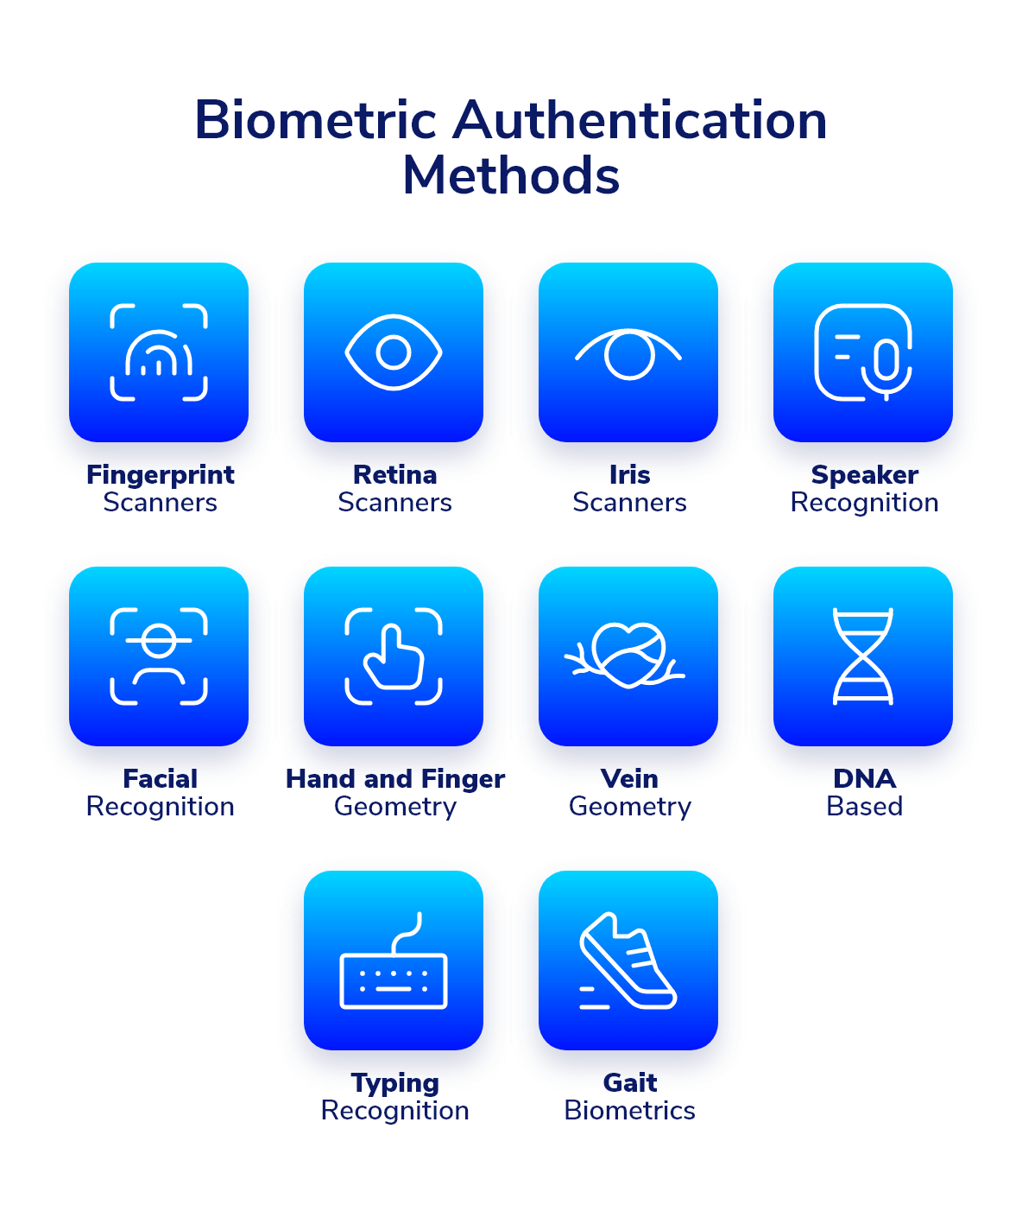
Figure 1: Authentication Methods (Li et al., 2022).
Enhancing Security with Biometric Authentication
In the ever-evolving landscape of cybersecurity, biometric authentication has emerged as a cutting-edge solution that enhances security by leveraging unique physiological and behavioral traits. This technology offers a multi-faceted approach to safeguarding sensitive data, systems, and physical spaces. Recent developments in biometric authentication underscore its significance in fortifying security measures (Li et al., 2021).
Deep Learning for Improved Accuracy: Recent advancements in deep learning have significantly enhanced the accuracy of biometric authentication systems. Convolutional neural networks (CNNs) and recurrent neural networks (RNNs) have been applied to improve the recognition accuracy of biometric traits. For instance, Li et al. (2022) introduced a novel deep neural network architecture for facial recognition, achieving state-of-the-art accuracy rates by learning hierarchical features.
Multi-Modal Biometrics for Robustness: To address limitations of single biometric traits, researchers are exploring multi-modal biometrics that combine multiple traits for enhanced security. A study by Singh et al. (2020) demonstrated that fusing fingerprint and iris recognition systems improved accuracy and reduced vulnerability to spoofing attacks.
Continuous Authentication for Dynamic Security: Continuous authentication is gaining prominence, particularly in scenarios where prolonged access is required. Utilizing behavioral biometrics, such as keystroke dynamics and gait analysis, researchers are enabling systems to continuously verify users during their sessions. Research by Li et al. (2021) showcased the effectiveness of continuous authentication in mitigating unauthorized access.
Anti-Spoofing Techniques: Biometric systems are susceptible to spoofing attacks using fake biometric samples. Researchers are actively developing anti-spoofing techniques to counter such threats. A recent contribution by Raghavendra et al. (2023) proposed a deep learning-based framework for detecting facial presentation attacks, thus bolstering the security of facial recognition systems.
Blockchain Integration for Data Integrity: Integrating biometric authentication with blockchain technology has gained traction for ensuring data integrity and preventing unauthorized changes to biometric templates. Gupta et al. (2022) introduced a blockchain-based biometric authentication system that provides tamper-proof storage and verification of biometric data.
Advantages and Disadvantages of Biometric Authentication
Biometric authentication has gained significant traction as a powerful security measure in various sectors. While it offers numerous advantages, it also comes with its share of disadvantages. Here's a balanced overview of the pros and cons of biometric authentication.
Advantages of Biometric Authentication
Enhanced Security: Biometric traits are unique to individuals, making them difficult to replicate, forge, or share. This uniqueness significantly reduces the risk of unauthorized access, identity theft, and fraud.
Convenience and User-Friendly: Biometric authentication eliminate the need for remembering complex passwords or carrying physical tokens. Users can authenticate themselves using traits that are intrinsic to them, such as fingerprints or facial features.
Non-Repudiation: Biometric authentication provides a strong basis for non-repudiation, ensuring that individuals cannot deny their involvement in a transaction or action. This is particularly useful in legal and financial contexts.
Reduced Risk of Theft and Loss: Biometric traits are not easily stolen or lost compared to passwords or tokens. This decreases the likelihood of unauthorized access through theft or loss of authentication credentials.
Dynamic Authentication: Certain biometric traits, such as keystroke dynamics or gait analysis, offer continuous and dynamic authentication during an ongoing session. This adaptability enhances security by accounting for variations in user behavior.
Multimodal Fusion: Combining multiple biometric traits in a multimodal approach increases accuracy and resilience. This fusion approach improves overall system performance and mitigates the risk of spoofing attacks.
Disadvantages of Biometric Authentication
Privacy Concerns: Collecting and storing biometric data raise privacy concerns. Individuals may worry about the misuse or unauthorized sharing of their sensitive physiological or behavioral information.
Irrevocability: Unlike passwords, biometric traits are difficult to change once compromised. If a biometric template is compromised, individuals cannot simply update it as they would with a password.
Accuracy and False Positives/Negatives: Biometric systems may occasionally produce false positives (incorrectly accepting an unauthorized user) or false negatives (rejecting an authorized user). Accuracy can be affected by factors such as lighting conditions, variations in trait presentation, or aging.
Spoofing and Presentation Attacks: Biometric systems are susceptible to spoofing attacks, where malicious actors use fake biometric samples to gain unauthorized access. Developing effective anti-spoofing techniques is an ongoing challenge.
High Implementation Costs: Setting up biometric authentication systems involves significant costs, including hardware, software development, integration, and maintenance. These costs can be prohibitive for smaller organizations.
Lack of Universality: Not all individuals have suitable biometric traits for authentication. Some people may have medical conditions or physical attributes that prevent accurate biometric recognition.
Conclusion
Biometric authentication has had a profound impact on enhancing security in various sectors. Its ability to provide a highly secure and personalized form of authentication, coupled with its user-friendly nature, makes it a valuable tool in the fight against cyber threats. While challenges persist, ongoing research and technological advancements are likely to further refine biometric authentication systems, making them an indispensable component of modern cybersecurity strategies. In the ever-evolving landscape of cybersecurity, biometric authentication stands as a formidable tool for enhancing security and streamlining user experience. Its unique attributes, such as non-repudiation, convenience, and resistance to theft, make it a crucial component of modern authentication strategies. Biometric technology's ability to dynamically adapt, integrate multimodal approaches, and counter certain forms of cyber threats further solidifies its position as a valuable asset in safeguarding digital identities and assets.
However, the adoption of biometric authentication is not without challenges. Concerns regarding privacy, accuracy, and the potential for spoofing attacks underscore the need for careful implementation and ongoing research. Organizations must strike a balance between harnessing biometric technology's benefits and addressing its drawbacks to create robust and ethical authentication systems.
Recommendations
- Prioritize user privacy by adhering to stringent data protection regulations and adopting practices that ensure secure collection, storage, and usage of biometric data.
- Whenever feasible, consider implementing multimodal biometric authentication, combining multiple traits for improved accuracy and resilience against spoofing attacks.
- Invest in robust anti-spoofing techniques that can detect and prevent presentation attacks, bolstering the reliability of biometric authentication systems.
- Educate users about the benefits and limitations of biometric authentication to foster acceptance and trust. Obtain clear and informed consent before collecting and using biometric data.
- Biometric systems should be regularly updated to account for changes in technology and security threats. This includes updating algorithms, software, and hardware components.
References
Gupta, P., Chatterjee, S., & Das, A. (2022). "Blockchain-Based Biometric Authentication for Data Integrity and Security. IEEE Transactions on Dependable and Secure Computing, 23(2), 23-37.
Islam, M. R., Islam, M. S., & Rahman, M. S. (2019). Biometric authentication systems: Robustness analysis against spoofing attacks. IEEE Access, 7(1), 80421-80439.
Jain, A. K., Ross, A., & Prabhakar, S. (2016). An introduction to biometric recognition. IEEE Transactions on Circuits and Systems for Video Technology, 14(1), 4-20.
Li, C., Chen, J., & Huang, Z. (2021). Continuous User Authentication with Keystroke Dynamics. IEEE Transactions on Information Forensics and Security, 16(2), 2809-2823.
Li, T., Zhang, Z., & Liu, J. (2022). Hierarchical Deep Neural Network for Face Recognition. IEEE Transactions on Image Processing, 31(1), 934-946.
Raghavendra, R., Raja, K. B., & Busch, C. (2023). "Deep Learning-Based Face Presentation Attack Detection using Both Visible and Thermal Modalities. IEEE Transactions on Information Forensics and Security, 18(1), 281-294.
Rashed-Al-Mahfuz, M., Al-Saggaf, A., & Islam, S. R. (2020). Acceptance of biometric authentication in developing countries: An empirical investigation. Information Technology for Development, 26(2), 286-307.
Singh, A. K., Kumar, A., & Tistarelli, M. (2020). Fusion of Iris and Fingerprint Biometrics: A Study on Multibiometric Systems. IEEE Access, 8(2), 154634-154648.
Statista. (2021). "Global public opinion on biometric technology. from https://www.statista.com/statistics/1181322/biometrics-technology-public-opinion-worldwide/
Wang, Z., Qi, X., & Lu, Y. (2022). "Fingerprint and Palmprint Multimodal Recognition Using Deep Learning. IEEE Transactions on Circuits and Systems for Video Technology, 17(1), 11-19.

